Project Development Phase

SPRINT-3

|  |  |
| --- | --- |
| Date | 10 November 2022 |
| Team ID | PNT2022TMID06337 |
| Project Name | Project - IOT Based Safety Gadget for Child Safety Monitoring Notification |

NODE RED-Cloudant DB Communication:

Step 1:Connections

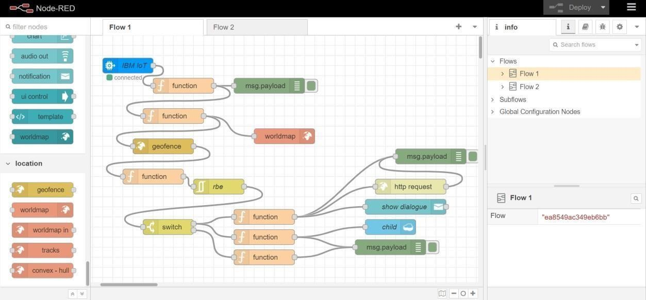

Step 2: Code in nodes

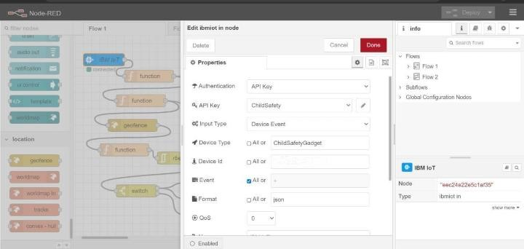

Step 3:Edit function mode(code)

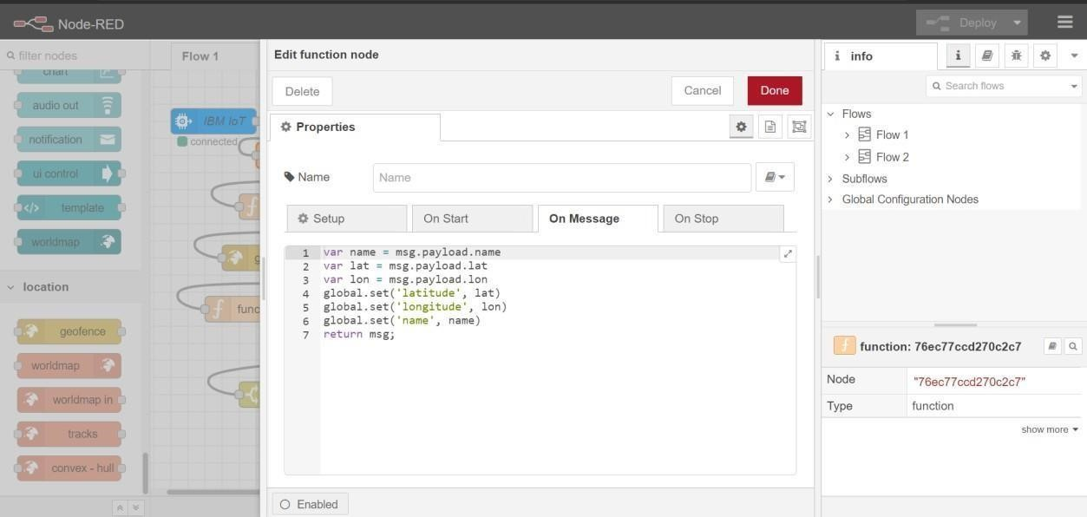

Step 4:

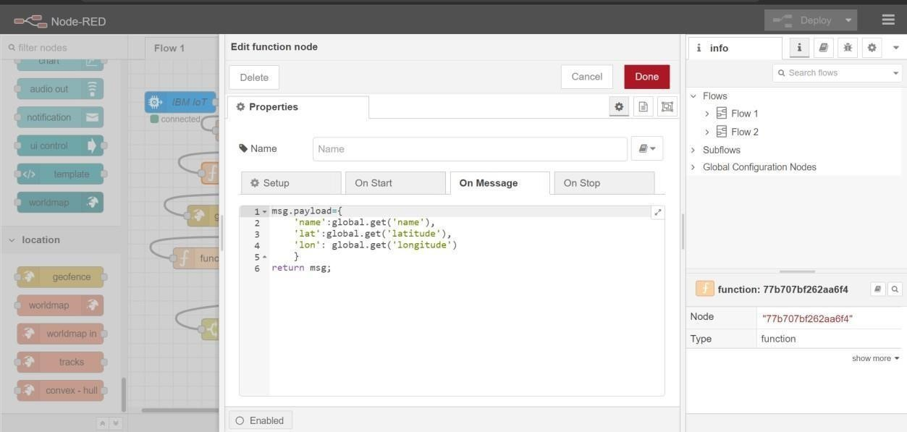

5: Geofencing mode

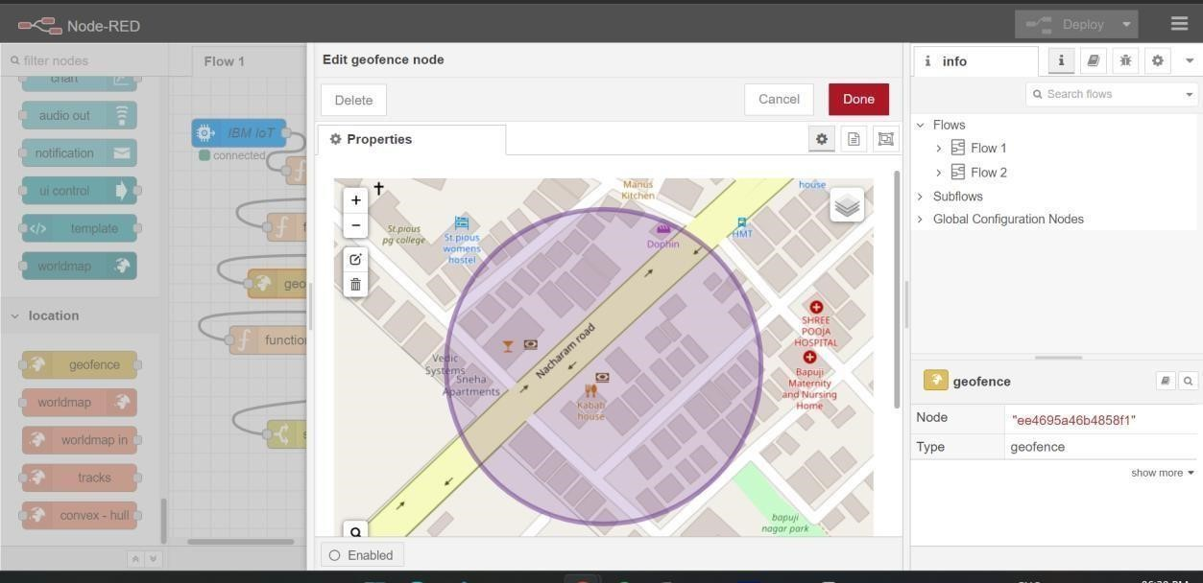

Step 6: Worldmap node with properties

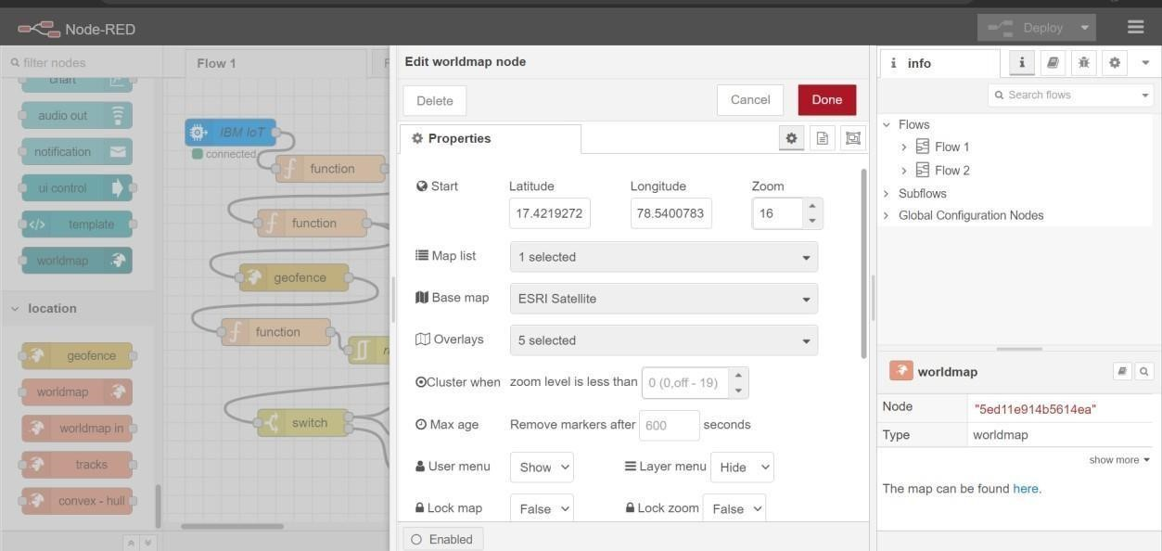

7:Apply the code with different node

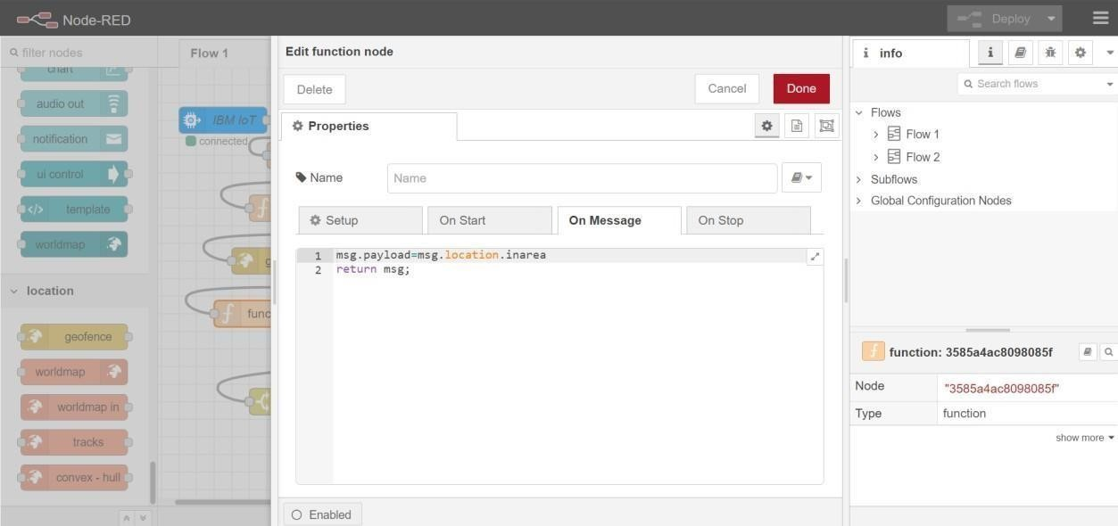

Step 8:Code with different node

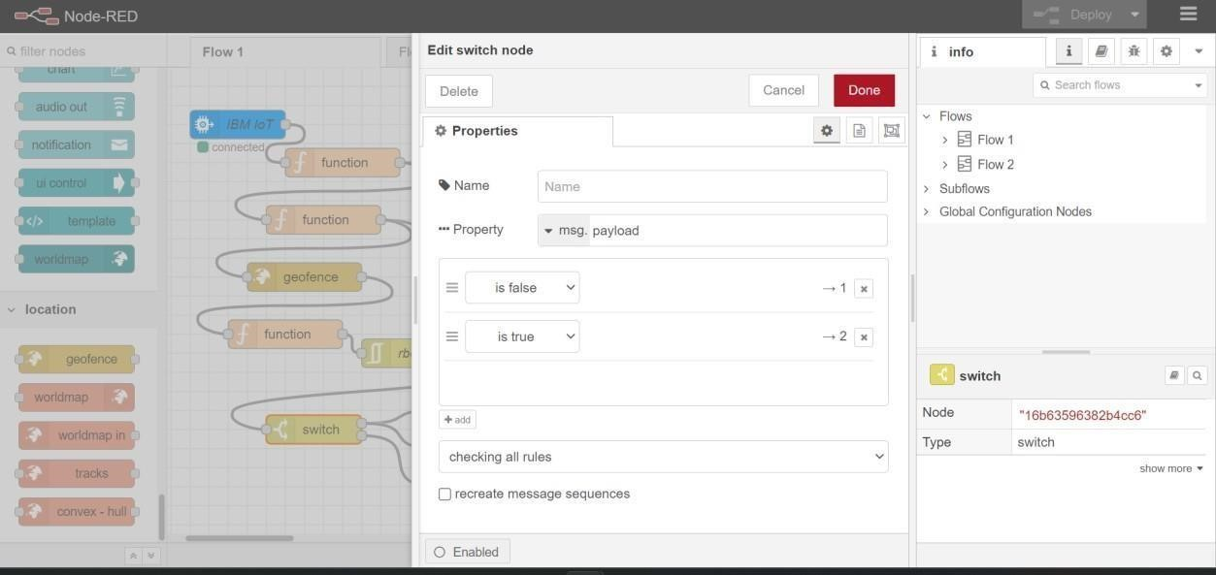

9:Code with different node

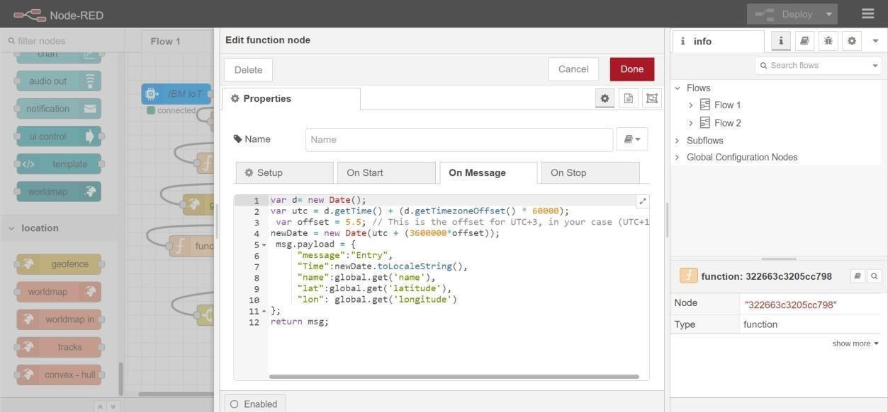

Step 10:code with different node

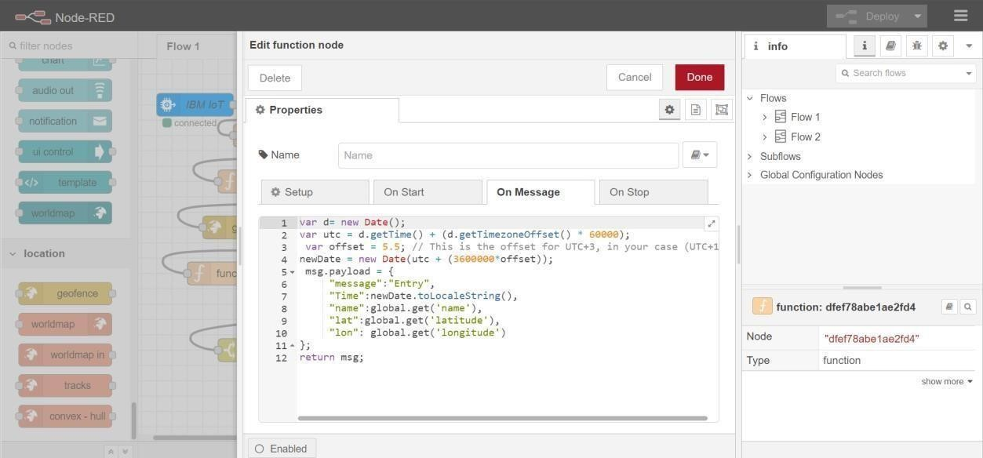

Step 11:Code with different node

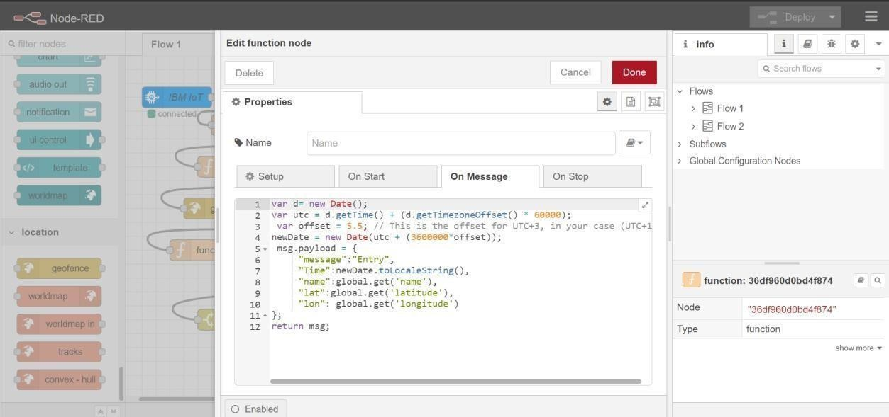

Step 12:Http request node->properties

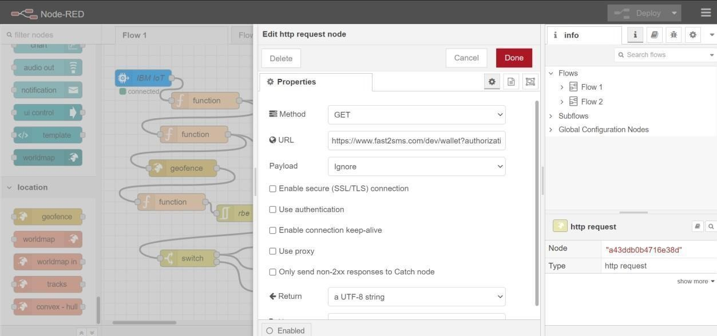

Step 13:Notification node

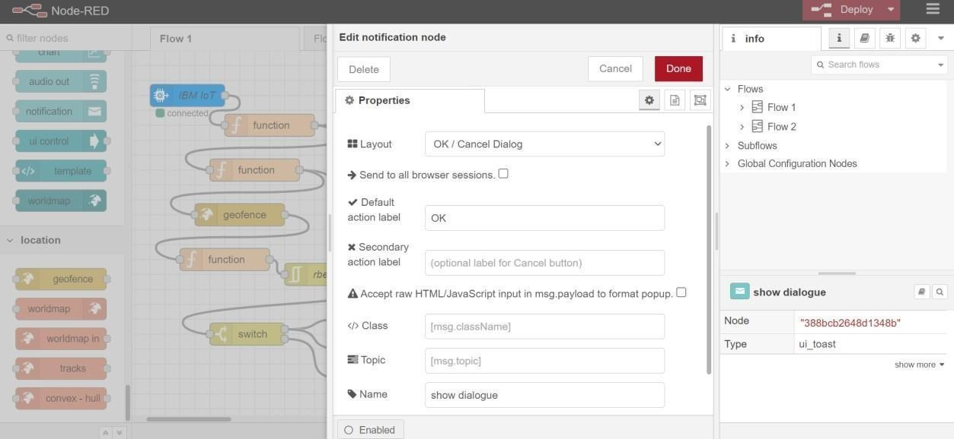

Step 14:Cloudant node

